Django Form Validation

Django provides built-in methods to validate form data automatically. Django forms submit only if it contains CSRF tokens. It uses uses a clean and easy approach to validate data.

The **is_valid()** method is used to perform validation for each field of the form, it is defined in Django Form class. It returns True if data is valid and place all data into a cleaned_data attribute.

Let's see an example that takes user input and validate input as well.

Django Validation Example

This example contains the following files and code.

31.4M

607

Difference between JDK, JRE, and JVM

**// models.py**

1. from django.db **import** models
2. **class** Employee(models.Model):
3. eid = models.CharField(max_length=20)
4. ename = models.CharField(max_length=100)
5. econtact = models.CharField(max_length=15)
6. **class** Meta:
7. db_table = "employee"

Now, create a form which contains the below code.

**// forms.py**

1. from django **import** forms
2. from myapp.models **import** Employee
4. **class** EmployeeForm(forms.ModelForm):
5. **class** Meta:
6. model = Employee
7. fields = "__all__"

Instantiate the form

Instantiate the form, check whether request is post or not. It validate the data by using **is_valid()** method.

**//views.py**

1. def emp(request):
2. **if** request.method == "POST":
3. form = EmployeeForm(request.POST)
4. **if** form.is_valid():
5. **try**:
6. **return** redirect('/')
7. except:
8. pass
9. **else**:
10. form = EmployeeForm()
11. **return** render(request,'index.html',{'form':form})

Index template that shows form and errors.

**// index.html**

1. <!DOCTYPE html>
2. <html lang="en">
3. <head>
4. <meta charset="UTF-8">
5. <title>Index</title>
6. </head>
7. <body>
8. <form method="POST" **class**="post-form" enctype="multipart/form-data">
9. {% csrf_token %}
10. {{ form.as_p }}
11. <button type="submit" **class**="save btn btn-default">Save</button>
12. </form>
13. </body>
14. </html>

Start server and access the form.

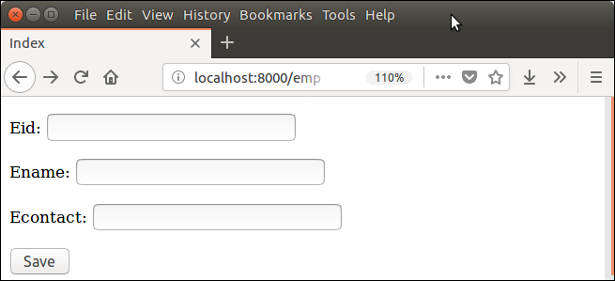

It validates each field and throws errors if any validation fails.

